**Offset of UK Property Disposal Capital Gains Tax**

* After submitting an in-year UK Property Disposals return, if the user needs to amend their figures, they can do so via the UK Property Disposals returnservice or via their Self Assessment tax return.
* If they amend via the UK Property Disposals returnservice, and their liability reduces, they can claim a repayment via the service. This will then be processed by HMRC.
* If the user amends via Self Assessment, they should complete the Self Assessment tax return with their overall Capital Gains Tax (CGT) residential property gains and the total gains or losses and tax charged via the UK Property Disposals returnservice.
* After all relevant sections of the Self Assessment tax return are completed, the user should go to the View your calculation Section and select the option to View and print your full calculation.

Example output (SA302) below:

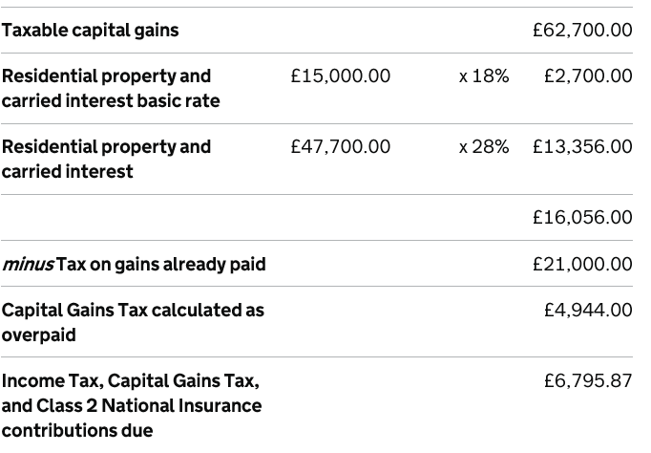

* The user can then pay the difference between the Income Tax, CGT and Class 2 NICs due figure and the CGT calculated as overpaid figure. In the example above £6,795.87 - £4,944.00 = **£1,851.87.** Please note that the Self Assessment payment deadline is the 31 January following the tax year.
* The user (or their agent if authorised to act on their behalf) should then contact HMRC to enable them to make a manual adjustment. The quickest way to get this resolved is by telephone on 0300 200 3300. If any further action is required by the user/agent HMRC will contact them to advise what that is.
* If the user chooses to make payment in full of the Income Tax, CGT and Class 2 NICs figure (£6,795.87), they should contact HMRC to request a repayment of their overpayment. This will then be reviewed by HMRC.
* Once the Self Assessment tax return has been submitted, the user should not attempt to amend their UK Property Disposals return for the corresponding tax year.