ICAEW
Professional Standards

ANTI-MONEY LAUNDERING POLICES AND PROCEDURES

Why do I need written anti-money laundering policies and procedures?
The Money Laundering and Terrorist Financing (Amended) 2017 regulations (MLTF) apply to your firm. They require you to have policies and procedures to ensure that you are compliant with the regulations. You are also required to document these policies and procedures.
The ICAEW is an AML supervisor and we expect all firms that we supervise to have documented their AML policies and procedures. We will apply a proportionate approach to documentation, taking into account the size of the firm and the complexity of the client base.
Who is the template aimed at?
This is targeted at new firms, sole practitioners and smaller firms who are looking for guidance on how to structure their AML policy and procedure documentation. You should review your AML policies and procedures on a regular basis to ensure they are still compliant and fit for purpose. You may find as the practice expands your procedures need to adapt accordingly.
Will this make my firm fully compliant with the Money Laundering Regulations?
The draft policies and procedures do not cover every eventuality. They are designed to suit the circumstances of a typical smaller accountancy practice. You should still ensure that you understand the money laundering regulations and any updates.
What should we do with this template?
Complete the template with relevant information and/or change it to reflect the circumstances of
your firm.
The areas that require you to add in your own references are highlighted in italic red font and grey background.
Guidance notes are in boxes and also within the text fields.
It is good practice to ensure this is readily available to all your staff and we would expect all staff to sign a declaration, at least annually to evidence that they have read, understood and will comply with your policies and procedures.
You should ensure that staff have regular AML training.
New staff should also understand the contents and have them explained to them by someone who is responsible for compliance with the money laundering regulations.

Anti-money laundering policies and procedures for Name of firm
Last updated 01/01/2021

Updated by name

Requirements
It is a legal requirement for our firm to have policies and procedures that comply with the Money Laundering, Terrorist Financing and Transfer of Funds (Information on the Payer) Regulations 2017 (MLR 17)
We are required to document these policies and procedures.
We take our obligations very seriously. We expect all staff to have read, understood and to comply with these policies and procedures by embedding processes within their daily work.
The 2020 National Risk Assessment judged accountants in the UK at a high risk of facilitating money laundering. All staff should be alert to this fact.
An individual or entity commits a Money Laundering offence if they;
- Conceal, disguise, convert or transfer criminal property (POCA 327),
- Acquire, use or possess criminal property (POCA 329);
- Are involved in an arrangement that allows another to acquire, retain, use or control criminal property (POCA 328);
- Remove criminal property from a UK jurisdiction (POCA 327).
Criminal property is any property that results from:
- Conduct in the UK that is criminal in the UK;
- Conduct overseas that would have been criminal had it taken place in any part of
the UK.
- The UK takes an ‘all crimes’ approach – including tax evasion and administrative offences.

money laundering Firm wide risk assessment
All firms are required to prepare a firm-wide risk assessment. A firm-wide risk assessment seeks to evaluate the money laundering risks that the whole business is exposed to. We have prepared our firm-wide risk assessment, and this is reviewed at least annually. It is important for you to understand the key money laundering risks that face our firm, and you can find our firm-wide risk assessment here

Internal controls
Note that in smaller firms it is likely that the person named in section 3.1 and 3.2 is likely to be the same individual.

Responsibility for compliance – Money Laundering Compliance Officer (MLCO)
The person appointed responsibility for ensuring name of firm complies with the Money Laundering Regulations is name of MLCO.

Responsibility for reporting – Nominated officer (NO)/Money Laundering Reporting Officer (MLRO)
Any circumstances which give a member of staff or agent rise to knowledge or suspicion or reasonable grounds for knowledge or suspicion that a person is engaged in money laundering or terrorist financing must be reported to name of NO/MLRO who will determine whether there are grounds to report to make a Suspicious Activity Report (SAR) to the National Crime Agency (NCA).

Changes
Any changes to these posts must be notified to ICAEW within 14 days.

Reporting of suspicious activity
This section should be adapted to fit the firm’s reporting practices.
An example is given below.

When do I report?
- All staff must report, every instance where they have knowledge or suspicion of MLTF to name of NO/MLRO without delay.
- In the regulated sector it is an offence for someone who knows or suspects that MLTF has taken place (or has reasonable grounds) not to report their concerns to their MLRO (or, in exceptional circumstances, straight to the NCA).
- There is no de Minimis, so you report regardless of scale

What is Suspicion?
Suspicion is:
- a state of mind more definite than speculation but falling short of evidence-based knowledge;
- a positive feeling of actual apprehension or mistrust;
- An opinion with some foundation.

CCAB guidance to help you decide whether to report is given below:
Step | Question
1 | - Do I have knowledge or suspicion of criminal activity? or  - Am I aware of an activity so unusual or lacking in normal commercial rationale that it causes a suspicion of MLTF?
2 | - Do I know or suspect that a benefit arose from the activity in 1?
3 | - Do I think that someone involved in the activity, or in possession of the proceeds of that activity, knew or suspected that it was criminal?
4 | - Can I identify the person (or persons) in possession of the benefit? or  - Do I know the location of the benefit? or  - Do I have information that will help identify the person (or persons)? or  - Do I have information that will help locate the benefits?

If in any doubt, make a report and the Nominated Officer/MLRO will take responsibility for deciding whether to report to the NCA.

Who do I report to?
- You report to the Nominated officer/MLRO.

How do I report?
- This should be done by using the Internal Money Laundering Report Form available to all to staff.

What happens next?
- An email acknowledgement of receipt of the form will be provided by the NO/MLRO to the member of staff.
- The nominated officer will decide whether it is appropriate to make a report to the National Crime Agency.
- The nominated officer will have a policy on Suspicious Activity Reporting. The policy includes:
  - How to report
  - When to report
  - How the NO/MLRO will gather sufficient information to report
  - Reference to NCA guidance on good quality SARs and the use of glossary codes
- They will document the reasons for their conclusion on whether to make an external report
- Any reports will be stored securely. Staff will not have access to reports.

What should I not do?
- Under no circumstances should the client or any of their representatives be advised that a report has been considered internally or that a suspicious activity report (SAR) has been made by the nominated officer, which may be considered Tipping Off and is an offence. The maximum penalties for committing the Failure to Report offence are 2 years imprisonment or an unlimited fine or both (POCA 333A and TA 21D). The maximum penalty for tipping off a money launderer is an unlimited fine and up to five-years imprisonment.

Customer Due Diligence (CDD)
Criminals often seek to mask their true identity by using complex and opaque ownership structures. The purpose of CDD is to know and understand a client’s identity and business activities so that any money laundering and terrorist financing risks can be properly managed. By knowing the identity of a client, including who owns and controls it, we not only fulfil our legal and regulatory requirements we equip ourselves to make informed decisions about the client’s standing and acceptability.
CDD and, in some cases, Enhanced Due Diligence (EDD) shall be performed (as set out in Chapter 5 and appendix B of CCAB guidance.
We have not included prescriptive guidance on the nature of your CDD procedures.
Practitioners wishing to add more detail to their policies and procedures in relation to CDD/EDD requirements should refer to CCAB guidance and add relevant details to this document.
Any policies and procedures in relation to use of electronic ID verification packages by a practice should be referred to in this section where relevant and the firm should ensure that engagement letters also reflect any use of electronic id packages.

New clients
When we take on a new client, we must apply client due diligence procedures as required by the money laundering regulations.
If we identify a discrepancy between the information that we gather, and the information that is on the PSC register or the HMRC Trust Registration Service, we must report that discrepancy to Companies House or HMRC as applicable. Link to guidance - Guidance on how to report.
Include your firm’s procedures where appropriate.
We identify the client; risk assess the client and verify the client.
Identifying the client requires an understanding of who the client is, for example if it is a corporate structure who are the beneficial owners so that the control structure can be understood.
The level of verification required will be linked to the level of risk we perceive of the client being involved in money laundering or terrorist financing. CCAB guidance 5.1.7 usefully provides the following summary of the stages of CDD.

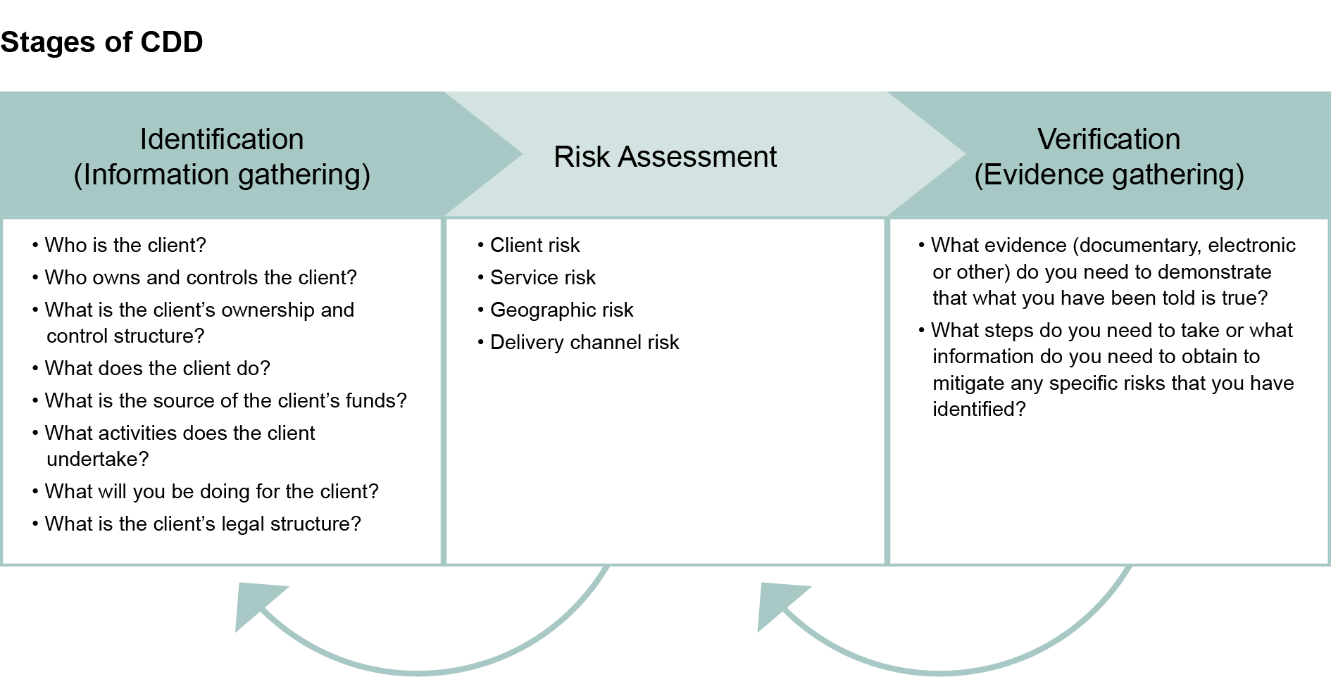

- For all new clients the following forms must be completed prior to undertaking any services for that client. The forms should be completed in full and submitted to name for review.
  - Name of new client risk AML assessment form
- Client take on must be approved by
  - Name of principal responsible for client approval

Enhanced due diligence
There will be situations/scenarios where we determine there is the potential for a higher risk of MLTF. In these cases, we must apply additional verification procedures. In the situations listed below we must always apply enhanced due diligence measures. These may include:
- a review of sanctions lists;
- enhanced monitoring of the client relationship,
- additional means of verification or we may refuse the transaction or client.
There may be other circumstances where we wish to apply enhanced due diligence. If you are in doubt, then consult. The completion of the client due diligence forms should highlight instances where we might wish to apply enhanced due diligence procedures.
If any of the conditions below apply we must apply enhanced due diligence:
- in any case identified as one where there is a high risk of money laundering or terrorist financing;
- in any business relationship or transaction with a person established in a high-risk third country;
  - High risk third countries are those identified as having strategic deficiencies in their anti-money laundering and counter-terrorist financing frameworks.
- where a customer or potential customer is a PEP, or a family member or known close associate of a PEP (in accordance with regulation 35);
  - The term 'politically exposed persons' (PEPs) refers to people who hold high public office.
- in any case where the relevant person discovers that a customer has provided false or stolen identification documentation or information and the relevant person proposes to continue to deal with that customer;
- in any case where—
  - a transaction is complex and unusually large, or there is an unusual pattern of transactions, and
  - the transaction or transactions have no apparent economic or legal purpose
There may be other situations where you may consider the client to be a higher risk and if you are unsure please consult with the NO/MLRO.

Ongoing monitoring
We use routine periodic reviews to update their CDD. The frequency of up-dating is risk based, making use of the business’ risk assessment covered in Chapter 4 of CCAB guidance, and reflecting our knowledge of the client and any changes in its circumstances or the services it requires.
Firm to include their own procedures in this regard e.g.: annual review of CDD – include links to any forms completed to evidence/complete ongoing due diligence.
We must also conduct ongoing monitoring of a business relationship, including:
- scrutiny of transactions undertaken throughout the course of the relationship (including, where necessary, the source of funds) to ensure that the transactions
are consistent with our knowledge of the customer, the customer’s business and
risk profile;
- undertake reviews of existing records and keeping the documents or information obtained for the purpose of applying customer due diligence measures up to date;
  - For example, changes in beneficial owners and ultimate beneficial owners; addresses; sources of wealth; business operations and nature of client base might all indicate a need for review of our knowledge of the client.

Record keeping
We will keep a copy of any documents and information obtained to satisfy the customer due diligence requirements in the regulations
We will keep the records specified above for at least five years beginning on the date on which we know or have reasonable grounds to believe that the business relationship has come to an end.
We will not seek to rely on client due diligence provided by third parties. If there are any circumstances which suggest that we might seek to do so the MLCP and/or the MLRO/NO must be consulted.

Monitoring
We must monitor our compliance with the money laundering regulations. To that effect the MLCO will perform an annual AML compliance review using the ICAEW compliance checklist. This will include a review of client files to ensure our procedures have been complied with.
Where there is a management board the results of monitoring should be provided to the board and any identified weaknesses addressed.

TRAINING
It is a requirement of MLR 2017 that staff undertake regular anti-money laundering and that a written record of the training delivered is maintained.
Arrangements for training are firm to add details of the training undertaken, how often it will be done and how this will be recorded.

Appendix 1

Internal Suspicious Activity Report
Submitted by Name
Date 01/01/2021
Please provide details of how you would like to be contacted in relation to this report.
Contact details
Where you have suspicion of money laundering or terrorist financing you must make an internal suspicious activity report. You must make the report to the MLRO. Please give the report to Name of MLRO You must not discuss this with anyone else as this could constitute ‘tipping off’.
Do not be concerned if you do not have all the information, we have asked for below. Just leave the box blank if you do not have the information to hand.
Any information provided is held securely and confidentially. Only the MLRO has access to this record. The MLRO will confirm receipt and contact you if they require further information. This will be done confidentially.
If you are not sure how to proceed with a client, please contact the MLRO for confidential advice.
Remember you must do nothing that would alert anyone to this report.
Client/victim Details | 1 |  | 2 | 3
Client Full name  (Include any middle names if you have them) | Client name |  | Client name | Client name
Associated Addresses | Address |  | Address | Address
Occupation | Occupation |  | Occupation | Occupation
Date of Birth | 01/01/2021 |  | 01/01/2021 | 01/01/2021
Telephone number | Telephone |  | Telephone | Telephone
Associated Businesses | Associated businesses |  | Associated businesses | Associated businesses
Involvement in activity | Activity |  | Activity | Activity
Any other identifying factors | Other factors |  | Other factors | Other factors
Are we aware of any involvement by law enforcement? | Law enforcement |  | Law enforcement | Law enforcement
Internal client reference | Reference |  | Reference | Reference
If client is a company | Company? |  | Company? | Company?
Company Name | Company name |  | Company name | Company name
Company Number | Company number |  | Company number | Company number
Registered office address | Registered address |  | Registered address | Registered address
Connected firms | Connected |  | Connected | Connected
Any other identifying information | Other info |  | Other info | Other info
Involvement in activity | Activity |  | Activity | Activity
Details that give rise to your suspicion. |  | Description
Why are you suspicious?  Is there an activity or transaction that has made you suspicious?  If so, provide as much information as possible.  Provide the information in chronological order of events |  | Reasons
When did the activity/event occur? |  | Date/time
Who do you suspect? |  | Who
Is there a victim? If so, provide details |  | Victim
If there are criminal proceeds what are they, it’s not necessarily money it could be property or high value items?  (Underpaid tax could be criminal proceed if deliberately withheld) |  | Criminal proceeds
Do you know the current location of criminal proceeds? |  | Current location
Do you know the value of the criminal proceeds? |  | Value
What service were you/are we providing? |  | Service providing

